

**Assignment Title**

University

Year 2023

**Third Assignment**

Labheshwar| 2K20/CSM/50

Visual Programming (C#)

Date of Submission: June 7, 2023

Academic Year: 2023

Institute of Mathematics & Computer Sience

**University of Sindh Jamshoro**

|  |  |
| --- | --- |
|  | OBJECTS AND PROPERTIES |
| Object | **Property** | **Setting** |
| OrderAndSummaryReportForm | Name  Text  AcceptButton  CancelButton | **OrderAndSummaryReportForm**  **Order and Summary Report enrollButton**  **exitButton** |
| coursesGroupBox | Name  Text  Font  FontSize | **coursesGroupBox**  **Courses**  **Corbel**  **12pt** |
| webDevRadioButton | Name  Text  Font  FontSize | **webDevRadioButton**  **Web Development 79.99**  **Corbel**  **10pt** |
| appDevRadioButton | Name  Text  Font  FontSize | **appDevRadioButton**  **App Development 89.99**  **Corbel**  **10pt** |
| mlRadioButton | Name  Text  Font  FontSize | **mlRadioButton**  **Machine Learning 99.99**  Corbel  1**0**pt |
| noCourseRadioButton | Name  Text  Checked  Visible | **noCourseRadioButton**  **invisible**  true  false |
| extrasGroupBox | Name  Text  Font  FontSize | **extrasGroupBox**  **Extras - $9.99 each**  **Corbel**  **12pt** |
| codingResourcesCheckBox | Name  Text  Font  FontSize | **codingResourcesCheckBox**  **Access To Coding Resources**  Corbel  1**2**pt |
| mentorshipCheckBox | Name  Text  Font  FontSize | **mentorshipCheckBox**  **Personal Mentorship**  Corbel  1**2**pt |
| jobPlacementCheckBox | Name  Text  Font  FontSize | **jobPlacementCheckBox**  **Job Placement Assistance**  Corbel  1**2**pt |
| selectCourseGroupBox | Name  Text  Font  FontSize | **selectCourseGroupBox**  **Select the course type**  Corbel  1**2**pt |
| webDevLabel | Name  Text  Font  FontSize | **webDevLabel**  **Web Development**  Corbel  1**1**pt |
| reactJsRadioButton | Name  Text  Font  FontSize  Checked | **reactJsRadioButton**  **React.js**  **Corbel**  **10pt**  **true** |
| angularRadioButton | Name  Text  Font  FontSize | **angularRadioButton**  **Angular.js**  **Corbel**  **10pt** |
| appDevLabel | Name  Text  Font  FontSize | **appDevLabel**  **App Development**  Corbel  1**1**pt |
| androidDevRadioButton | Name  Text  Font  FontSize | **androidDevRadioButton**  **Android Development**  **Corbel**  **10pt** |
| iosDevRadioButton | Name  Text  Font  FontSize | **iosDevRadioButton**  **iOS Development**  **Corbel**  **10pt** |
| flutterDevRadioButton | Name  Text  Font  FontSize | **flutterDevRadioButton**  **Flutter Development**  **Corbel**  **10pt** |
| quantityLabel | Font  FontSize  Name  Text | **Corbel**  **12pt**  **quantityLabel**  **Number of Persons** |
| quantityTextBox | Name  Text | **quantityTextBox**  **(Blank)** |
| itemPriceLabel | Font  FontSize  Name  Text | **Corbel**  **12pt**  **itemPriceLabel**  **Item Price** |
| itemPriceTextBox | Name  Text  ReadOnly  TabStop | **itemPriceTextBox**  **(Blank)**  **true**  **false** |
| enrollButton | Name  Text  Font  FontSize | **enrollButton**  **Enroll**  **Corbel**  **12pt** |
| enrollmentCompleteButton | Name  Text  Font  FontSize  Enabled | **enrollmentCompleteButton**  **Enrollment Complete**  **Corbel**  **12pt**  **false** |
| summaryReportButton | Name  Text  Font  FontSize  Enabled | **summaryReportButton**  **Summary Report**  **Corbel**  **12pt**  **false** |
| exitButton | Name  Text  Font  FontSize | **exitButton**  **Exit**  **Corbel**  **12pt** |

**CODE**

/* Project: Sales Form

* Programmer: Labheshwar

* Roll Number: (2K20/CSM/50)

* Description: This project generated summary report for orders and enrollments.

* This project calculates the amount due based on the customer selection and

* accumulates summary data for the day.

* Includes error trapping and summary calculations.

*/

using System;

using System.Collections.Generic;

using System.ComponentModel;

using System.Data;

using System.Drawing;

using System.Linq;

using System.Text;

using System.Threading.Tasks;

using System.Windows.Forms;

namespace OrdersAndSummaryReport

{

public partial class OrderAndSummaryReportForm : Form

{

// Declare Class Variables

private decimal itemPriceDecimal, totalOrderDecimal, totalSalesDecimal;

private int coursesInteger, ordersInteger;

public OrderAndSummaryReportForm()

{

InitializeComponent();

}

private double totalItemPrice() {

double itemPrice=0;

if (webDevRadioButton.Checked)

{

itemPrice = 79.99;

}

else if (appDevRadioButton.Checked)

{

itemPrice = 89.99;

}

else if (mlRadioButton.Checked)

{

itemPrice = 99.99;

}

if (mentorshipCheckBox.Checked)

{

itemPrice += 9.99;

}

if (jobPlacementCheckBox.Checked)

{

itemPrice += 9.99;

}

if (codingResourcesCheckBox.Checked)

{

itemPrice += 9.99;

}

return itemPrice;

}

private void enrollButton_Click(object sender, EventArgs e)

{

// Add the current item price and quantity to the order.

if (noCourseRadioButton.Checked)

{

MessageBox.Show("You must select a course.",

"Missing Required Entry");

}

else {

try

{

int quantityInteger = int.Parse(quantityTextBox.Text);

if (quantityInteger != 0)

{

coursesInteger += quantityInteger;

itemPriceDecimal = (decimal)totalItemPrice();

totalOrderDecimal += itemPriceDecimal * quantityInteger;

enrollmentCompleteButton.Enabled = true;

// Reset Default for next item.

noCourseRadioButton.Checked = true;

reactJsRadioButton.Checked = true;

codingResourcesCheckBox.Checked = false;

jobPlacementCheckBox.Checked = false;

mentorshipCheckBox.Checked = false;

itemPriceTextBox.Clear();

quantityTextBox.Text = "1";

}

else {

MessageBox.Show("Please enter a quantity.",

"Missing Required Entry");

}

} catch (FormatException) {

MessageBox.Show("Invalid Quantity.", "Data Entry Error");

quantityTextBox.Focus();

quantityTextBox.SelectAll();

}

}

}

private void enrollmentCompleteButton_Click(object sender, EventArgs e)

{

// Enrollment is complete, add to summay and clear order.

// Check if the last enrollment was added to the total

if (itemPriceTextBox.Text != "") {

DialogResult responseDialogResult;

string messageString = "Current Item not recorded. Enroll first!";

responseDialogResult = MessageBox.Show(messageString,

"Verify Last Enrollment",

MessageBoxButtons.YesNo,

MessageBoxIcon.Question);

if (responseDialogResult == DialogResult.Yes) {

enrollButton_Click(sender, e);

}

}

// Display amound due

string dueString = "Amount Due " + totalOrderDecimal.ToString("C");

MessageBox.Show(dueString, "Enrollment Complete");

// Add to summary totals.

ordersInteger++;

totalSalesDecimal += totalOrderDecimal;

// Reset buttons and total for new order.

summaryReportButton.Enabled = true;

enrollmentCompleteButton.Enabled = false;

totalOrderDecimal = 0m;

}

private void summaryReportButton_Click(object sender, EventArgs e)

{

// Display the summary information in a message box.

string summaryString = "Courses sold: "

+ coursesInteger.ToString()

+ "\n\n" + "Number of Orders: "

+ ordersInteger.ToString()

+ "\n\n" + "Total Sales: "

+ totalSalesDecimal.ToString("C");

MessageBox.Show(summaryString,

"CodeLab Courses Sold Summary Report",

MessageBoxButtons.OK,

MessageBoxIcon.Information);

}

private void exitButton_Click(object sender, EventArgs e)

{

this.Close();

}

}

}

**Graphical User Interface**

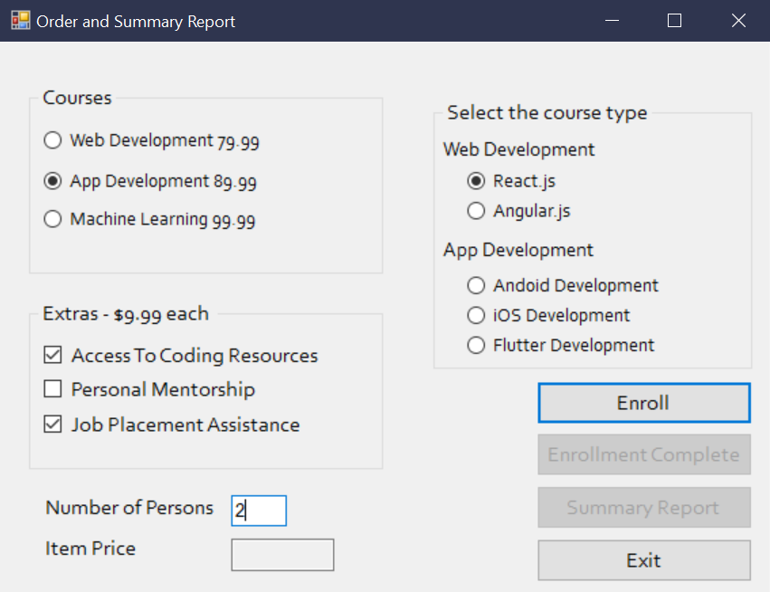

**Enrollement Complete**

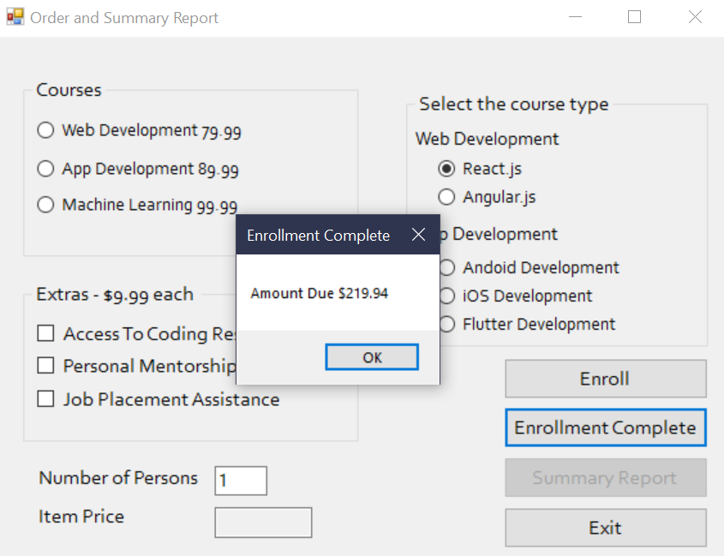

**Summary Report**

